Ahmed Ehab Ahmed
MongoDB Lab3

a- Display employees fullname and department name for all employees
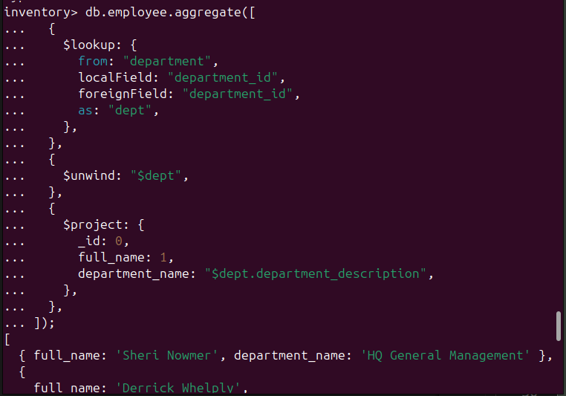
b- Display employees with position “VP Country Manager” (only display employee full name and salary).
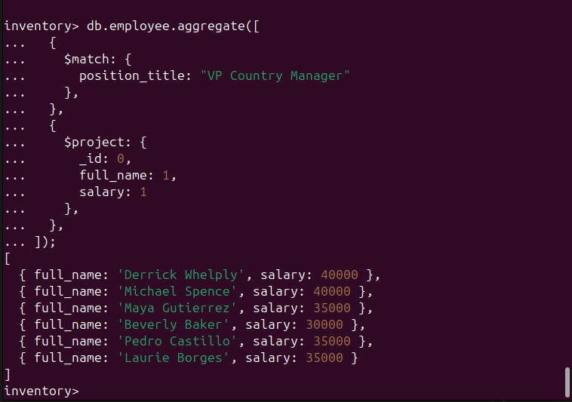
c- Display customers full names and their regions.
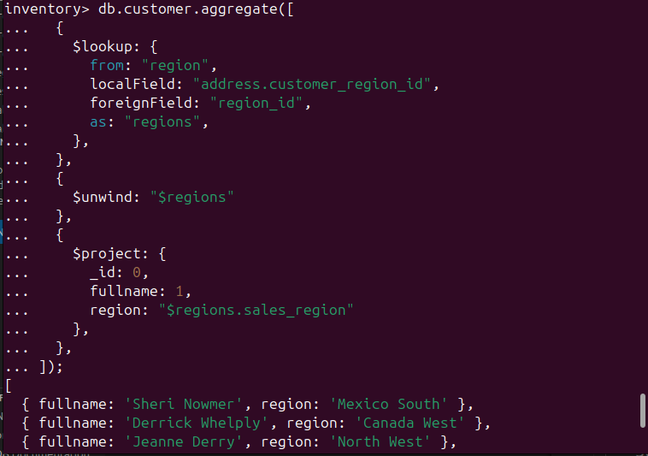
d- In product find all products that was branded by " Washington " (try to createIndex on brand_name and test your query speed)
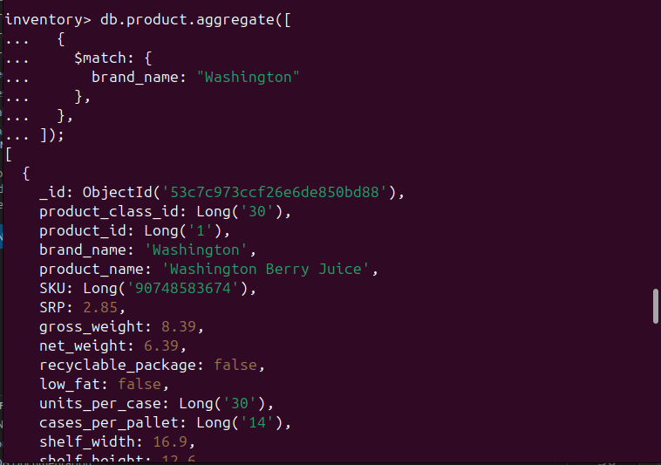

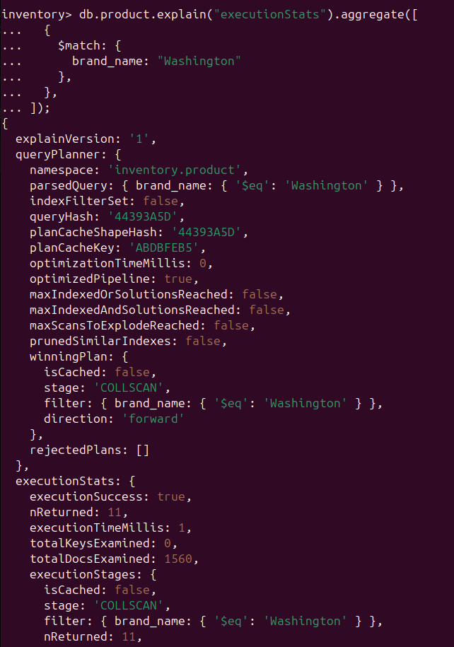
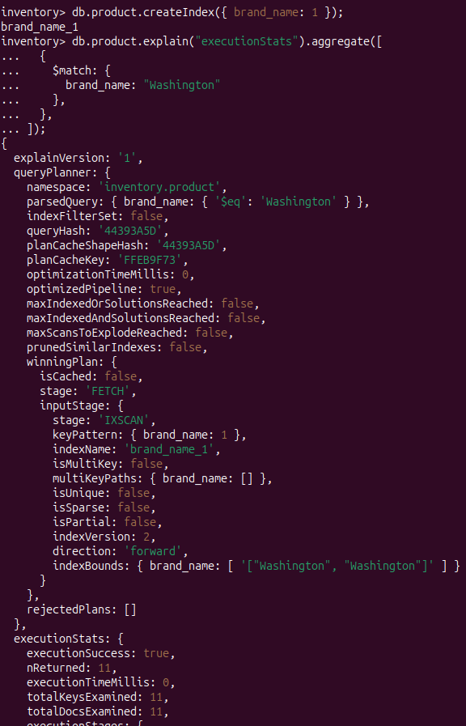
a- Group products by brand name, count number
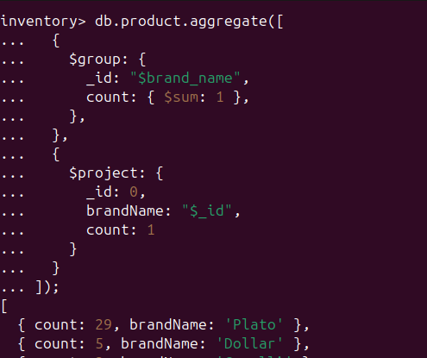
b- Group products by brand_name and product_name ,only select brand names ("Blue Label","King","Washington") then sort them by brand_name and product_name ascending
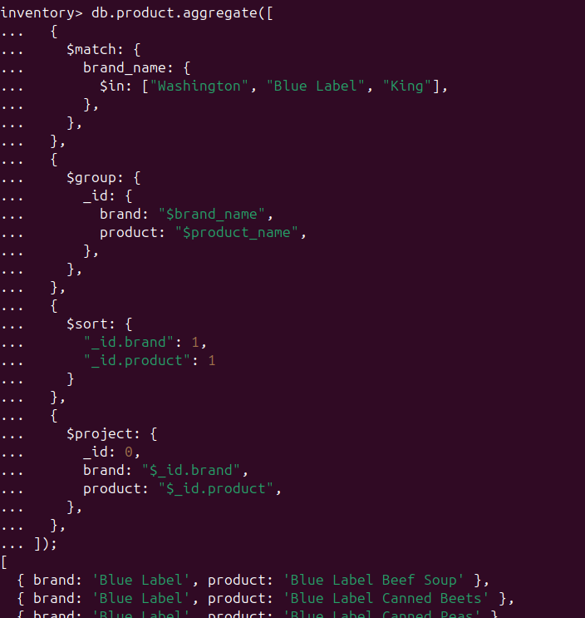
BONUS:Display maximum salary for each department (display department name and maximum salary)
